Notes on CPIC development

Most recent updates:

1. README for CPIC Genotype to phenotype KO instructions on how to use the wizard and operate the KO done. Waiting for Tina to test and provide feedback.
2. CYP2C19, Escitalopram and Citalopram KO made
3. Phenytoin is for CYP2C9 gene. Also updated Clopidogrel to take “Normal metabolizer” instead of   
   “Extensive metabolizer” which is an older term.
4. 2-2-2018 New phenotype-recom for demo has been created for CYP2D6-Codeine, CYP2C19-Phenytoin, CYP2C19-Clopidogrel. Located in FInished_KO_for_Prototype folder.
5. 1-31-2018 Improved CPIC_GPWizard(v1.3).py released. Payload has been upgraded to skeleton_geno_pheno-base(v1.2).py
6. 1-31-2018 Some excel geno-pheno tables contain complex alleles. Created ‘Table_tool_kit’, a jupyter notebook file that can return all unique values contained in each column to get an overview of all possible values contained in the table.
7. 1-31-2018 Created skeleton_geno_pheno-base(v1.2).py to handle complex alleles containing non numerical characters. Previously, it could only handle numerical values, and the comparison step to reorder the alleles based on numerical value would cause an error.
8. Improved CPIC_GPWizard(v1.2).py. Fixed bug that existed on payload which prevented users from inputting allele specifications without ‘*’ format.
9. Removed “phenotype” dictionary key. Only diplotype, allele1 and allele2 retained
10. Edited Input xml to reflect reduction in parameters passed. Deleted phenotype and adjusted number of parameters from 4 🡪 3.
11. Edited Build.py in MakeKO file to be compatible for python3.
12. Created CPIC_GPWizard(v1.1).py. This wizard has been updated to contain the latest updated skeleton code for the genotype to phenotype payload, as well as an updated inputxml.
13. Emailed James Hoffman about questions.
14. CPIC_GPWizard(v1.1).py modified to generate ark ID using file name
15. Comments explaining how to use the skeleton geno-pheno (payload code) results in an error when running. REMOVED for the Wizard.
16. Early stage prototype phenotype to recommendation KO created for UGT1A1
17. Much reformatting needed for UGT1A1: Removed superscript “c” and “d”, and fixed “metazolizer” to “metabolizer”.

Current work:

1. Make KO for amitriptyline. (recommendations with the biggest effect get priority. Don’t return multiple suggestions. Make it smart at handling multiple recommendations.)
2. When the gene folder is located in a different file, the wizard will still make the KO, but the naming will be off. Perhaps play around with regular expressions to solve this issue.
3. Create KO for CYP2C19 and CYP2D6. Generate altered CYP2D6 to contain “Indeterminate” entries.
4. Re-visited the Wizard. How can we customize this? Improve speed?
5. Testing: Have Tina follow READ_ME for CPIC_Wizard to see if it makes sense.

Questions/Concerns:

1. UGT1A1 Miss spelled “metazolizer”
2. Difference in formatting from the 2013 paper vs 2015 paper. Something to keep in mind as we create phenotype to recommendation KO because the header names are different. Need to set a standard.

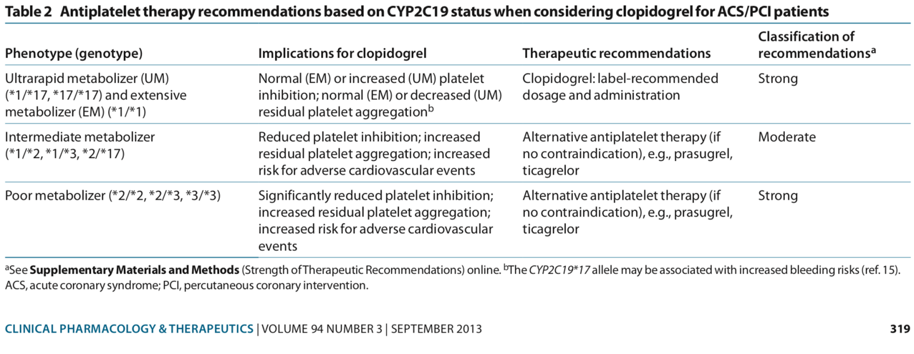

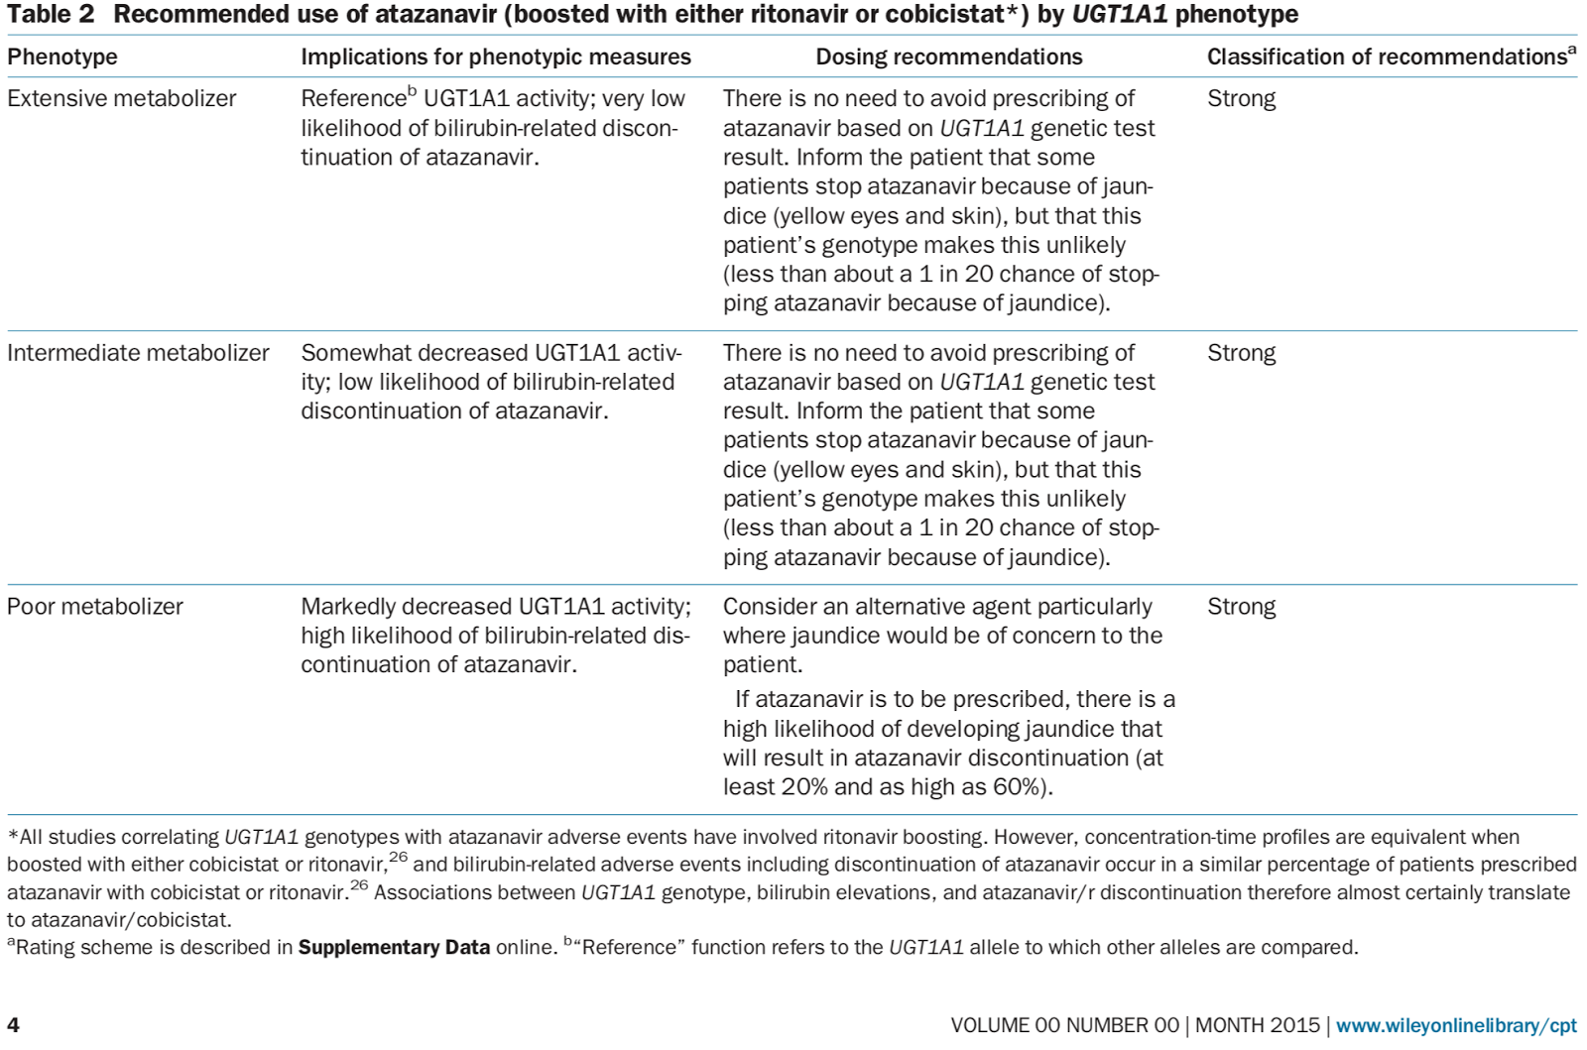

1. The CYP2C19 table has rapid metabolizer, intermediate metabolizer, likely intermediate metabolizer (treat as intermediate according to CPIC people), likely poor metabolizer, and poor metabolizer. The paper on CYP2C19 published in 2013 contains extensive metabolizer which does NOT exist in the table.